**User Story Mapping**

First, the user should be asked about their system preferences. In this case, friends and people around is choosed as the users related to the system. Feedback from at least 10 real users have be obtained and documented. Software such as Trello is utilized to accomplish this task.

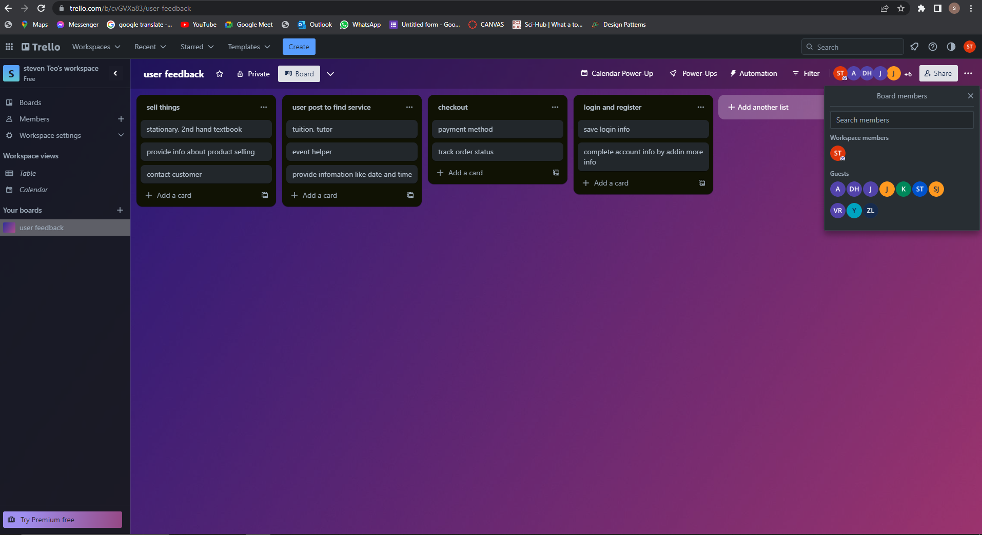

User Story Mapping: Student Business System for College.



Introduction:

At the outset, students are required to register an account to gain access to the Student Business for College system. Existing users can log in directly, while new users can provide additional information such as their birthday, favorite products, and interested categories to complete their account profile.

User Roles and Features:

Once registered, users can seamlessly switch between the roles of seller and customer without the need for a separate account. As a seller, users can easily manage their business by adding, deleting, and editing product information within the "My Shop" section. Additionally, users can offer services such as tutoring or event assistance. In the event that a product is sold out, users have the option to either permanently delete the product information or retain it for future reference. Furthermore, users can maintain communication with customers who have purchased their items to address any potential issues.

For customers looking to purchase products, the system provides several convenient features. Users can search for specific products using keywords, browse through different categories, and utilize advanced search filters such as price, rating, and payment options. Detailed product descriptions and previews are available to help customers make informed decisions. Once a desired item is identified, customers can add it to their basket and choose to proceed with immediate checkout or save it for later. During the payment process, customers have the ability to select their preferred payment method, apply discount promo codes, and even use coupons. Furthermore, users can track the status of their previous orders and receive information regarding estimated delivery dates. In the event of any changes or inquiries, customers can directly contact the seller through provided contact numbers or online chat support. Upon receiving the product or completing the service, customers can rate their experience through comments, image uploads, and rating stars.

Finding Services:

In addition to buying and selling products, users of the system can also post requests to find services. Whether it's looking for a tutor, an event helper, or any other service, users can create posts specifying their requirements. This allows other users who offer the desired services to respond and engage in potential business opportunities. The system facilitates seamless communication between service seekers and providers, ensuring efficient coordination and satisfaction.

Customer Support:

Lastly, the system offers comprehensive customer support. Users can contact the support team through a dedicated phone number to address any queries or submit complaints, ensuring a seamless user experience.

Conclusion:

The Student Business for College system simplifies the process of buying and selling for students. With its user-friendly interface and versatile features, students can effortlessly engage in commerce, conveniently manage their businesses, find services, and enjoy efficient customer support.